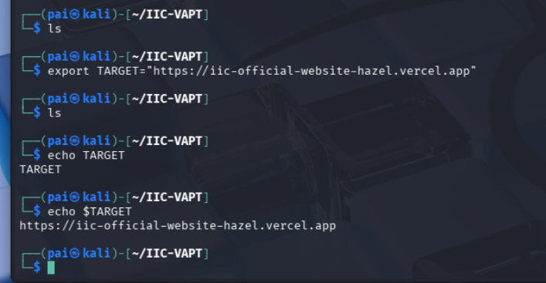

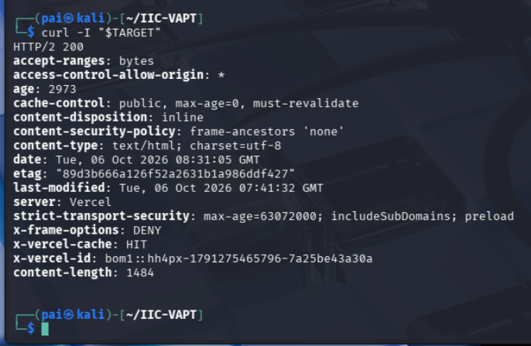
The target responded successfully over HTTP/2 with status code 200. The response identifies Vercel as the serving platform. HTTP Strict Transport Security is enabled, and the response includes X-Frame-Options: DENY. The response also contains a CSP frame-ancestors 'none' directive. Access-Control-Allow-Origin: * is present and requires further context-specific CORS testing.
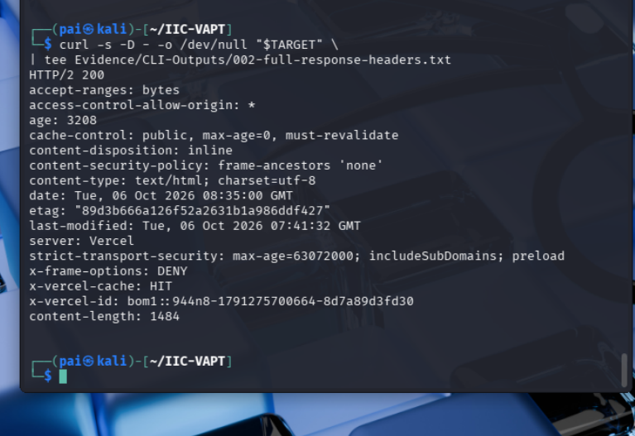
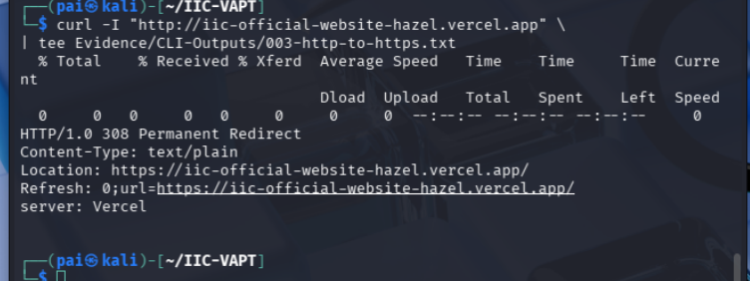
The 308 is appropriate because it permanently redirects the HTTP request to HTTPS while preserving the HTTP method if necessary.
The HTTP endpoint was tested to determine whether requests are redirected
to the secure HTTPS endpoint.
The server returned HTTP 308 Permanent Redirect and directed the request
to the HTTPS version of the application.
Result: PASS
Evidence:
Evidence/CLI-Outputs/003-http-to-https.txt
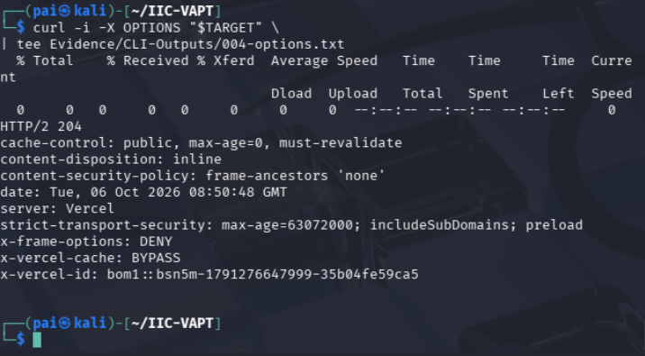
The HTTP OPTIONS method was sent to the application's root endpoint.

The server returned HTTP 204 No Content. No Allow or
Access-Control-Allow-Methods header was observed in the response.

The response alone does not establish an insecure HTTP-method
configuration. Further method testing will be performed only against
identified application endpoints where the relevant methods are expected.

Result: No finding identified at this stage.

Evidence:
Evidence/CLI-Outputs/004-options.txt

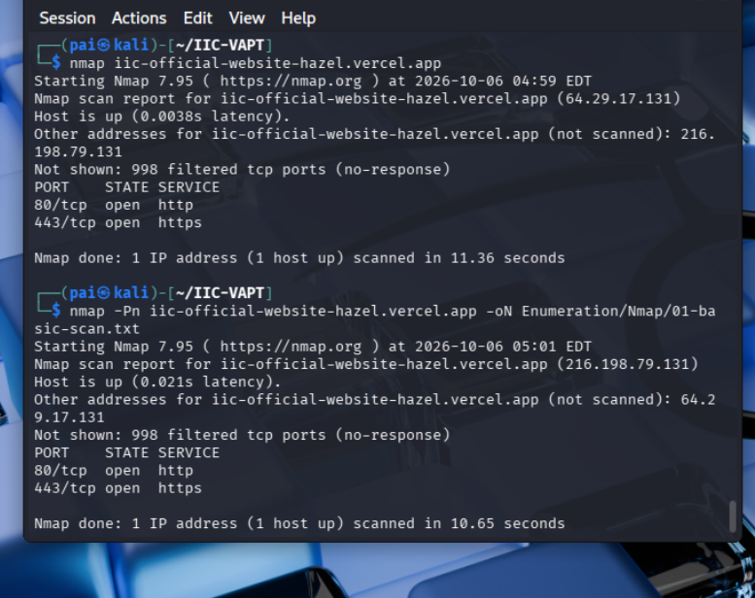
Network enumeration identified HTTP and HTTPS as the externally accessible services. No additional exposed TCP services were identified in the tested port range.
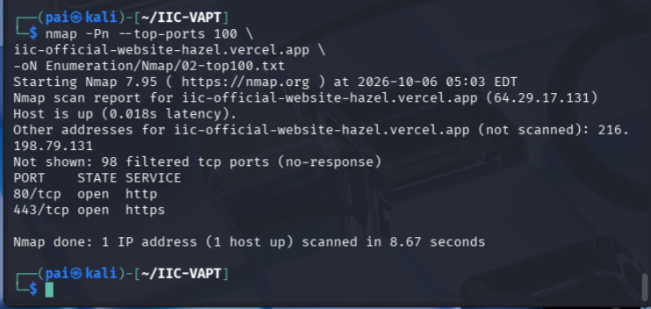
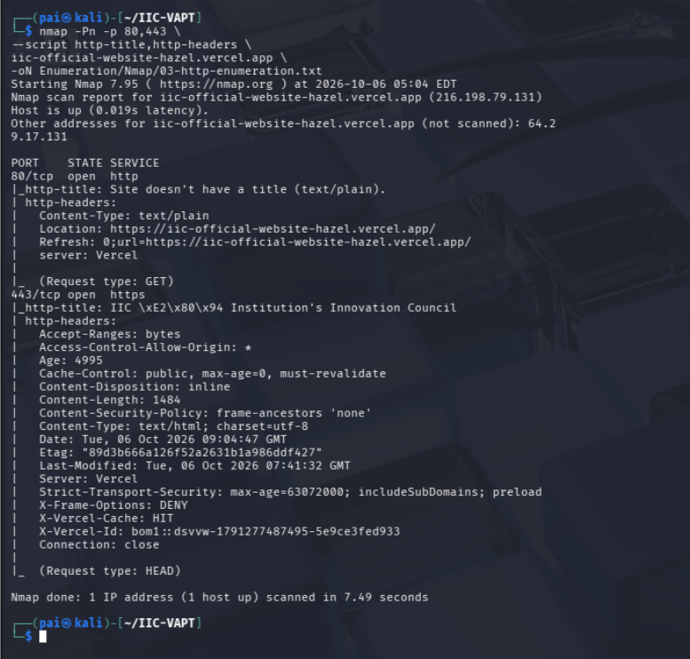
Tool: Nmap 7.95

Tests performed:
- Host/service discovery
- Top 100 TCP ports
- HTTP/HTTPS service enumeration

Results:
- TCP/80: HTTP
- TCP/443: HTTPS
- Remaining tested ports: filtered/no response
- HTTP redirects to HTTPS
- HTTPS identifies the application title as "IIC | Institution's Innovation Council"
- Server infrastructure identifies as Vercel

Assessment:
No network-level vulnerability was identified.

Note:
The application is deployed on Vercel. Observed hosting IP addresses and
platform-level infrastructure are therefore not treated as dedicated IIC
infrastructure.

